LOAD BALANCER

1.CREATE SECURITY GROUP

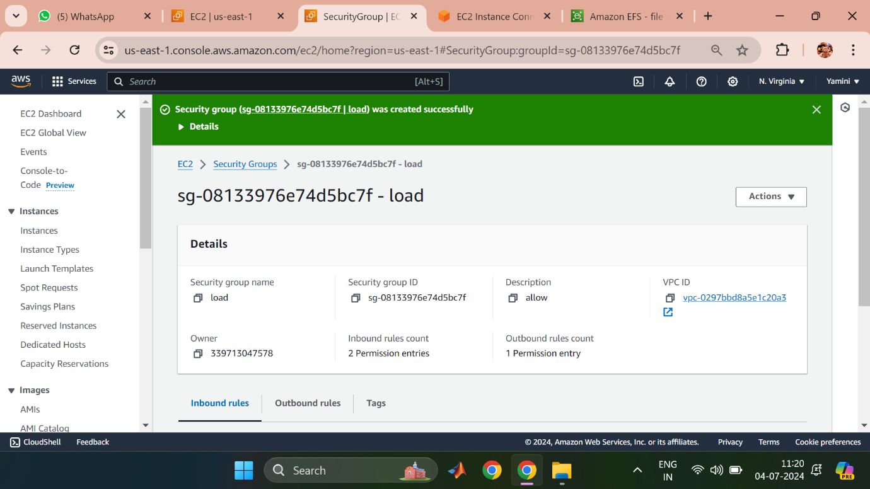

2.CREATE INSTANCES

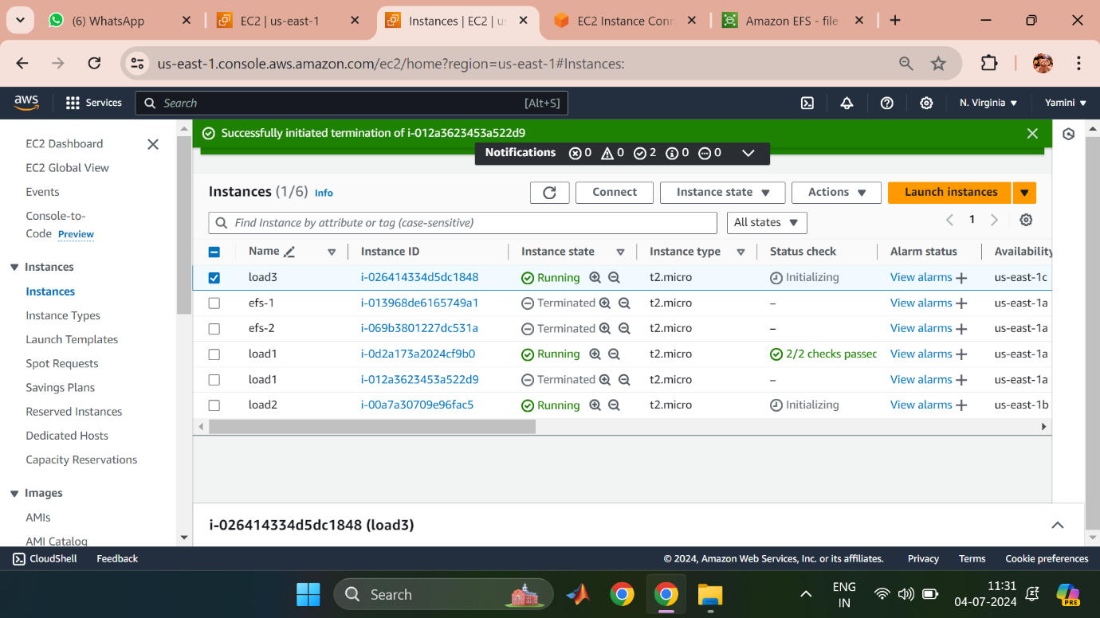

3.CONNECT INSTANCE

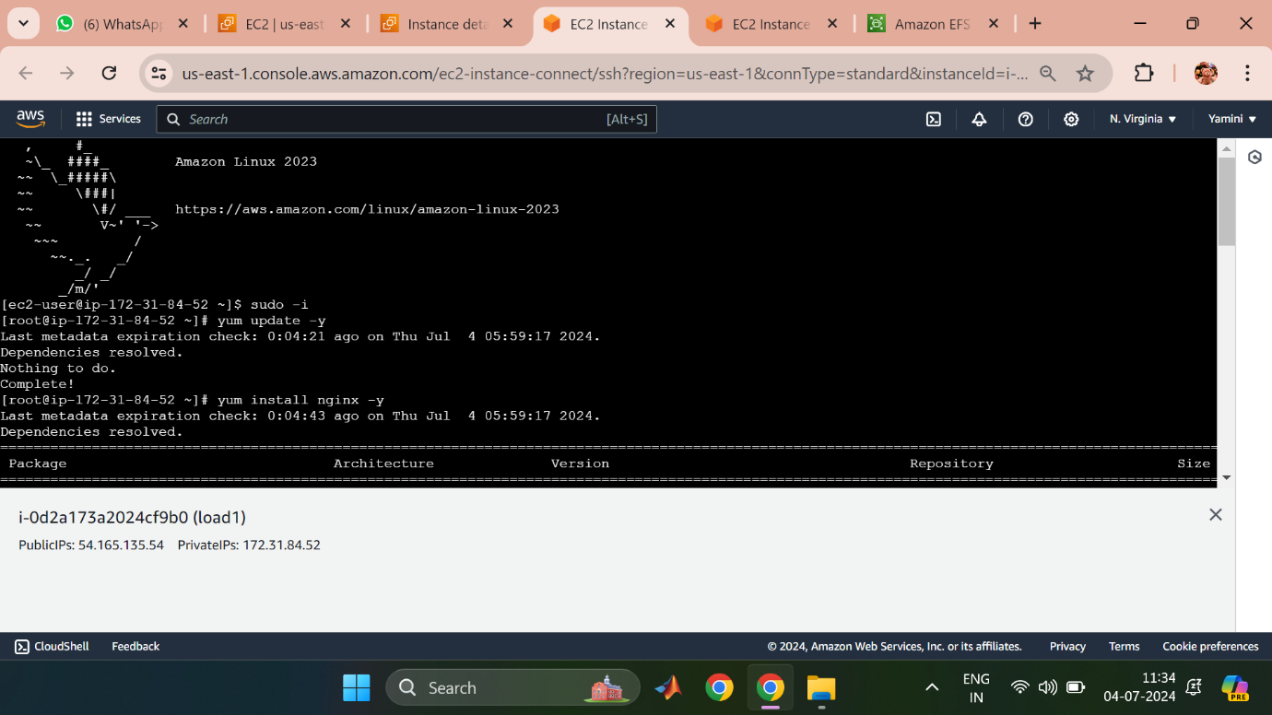

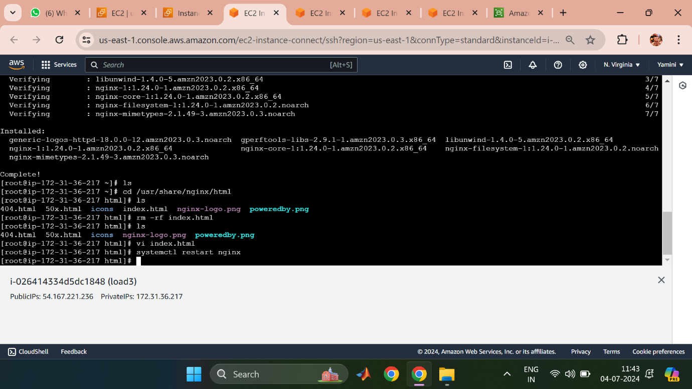

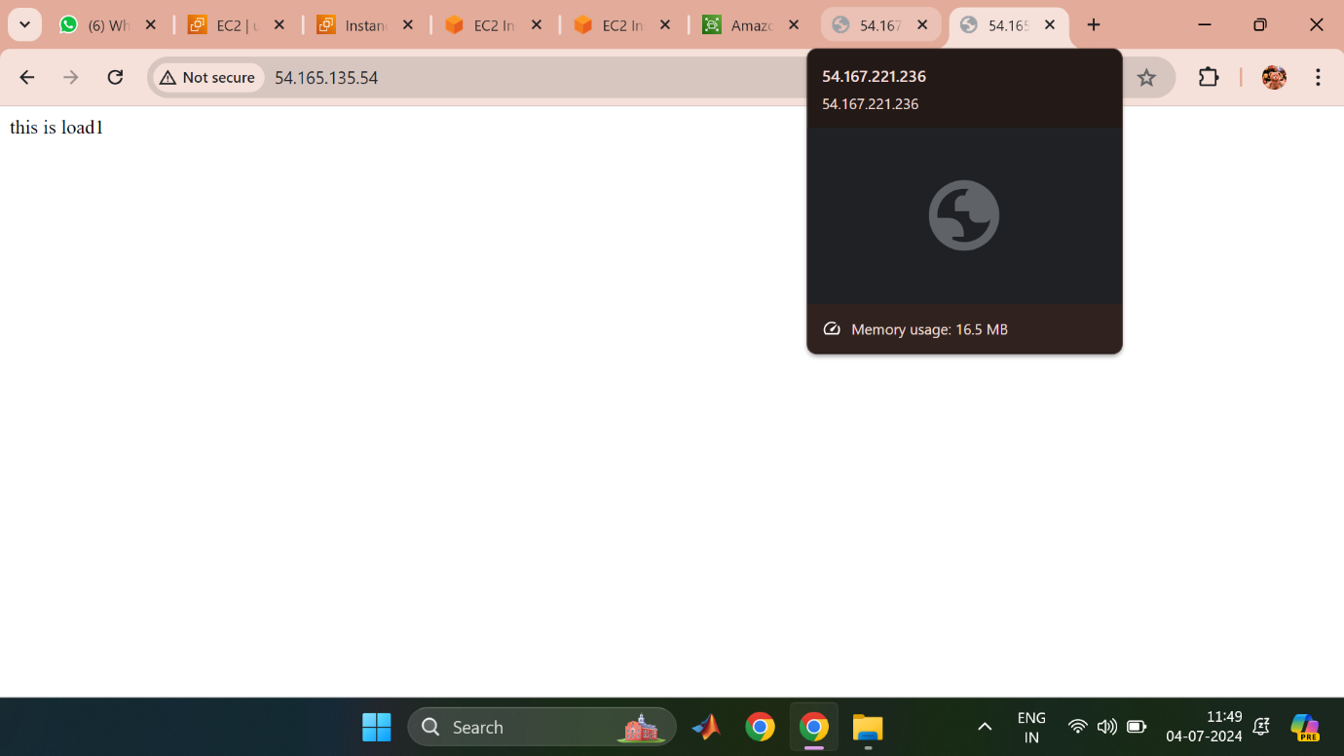

Similarly,Load2,Load3 follows the same process as shown in the above figure.

4.CREATE TARGET GROUP

